MEDICAL DIAGNOSIS
AIM
To develop a medical diagnosis system using Prolog that identifies a possible disease based on the symptoms given by the user.
OBJECTIVE
· To represent medical knowledge using Prolog facts and rules.
· To accept symptoms as input.
· To apply logical inference for diagnosis.
· To display the possible disease based on matching symptoms.
ALGORITHM
1. Start the program.
2. Define symptoms as Prolog facts.
3. Define diagnosis rules for different diseases.
4. Enter the patient's symptoms.
5. Match the symptoms with the predefined rules.
6. If a rule matches, identify the possible disease.
7. Display the diagnosis.
8. If no rule matches, display an unknown diagnosis.
9. Stop the program.
FLOWCHART
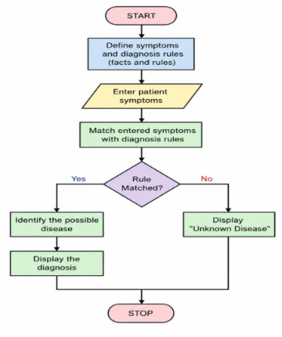
CODE
% Medical Diagnosis System
diagnosis(flu) :-
symptom(fever),
symptom(cough),
symptom(body_pain).
diagnosis(cold) :-
symptom(cough),
symptom(runny_nose),
symptom(sneezing).
diagnosis(malaria) :-
symptom(fever),
symptom(chills),
symptom(sweating).
diagnosis(typhoid) :-
symptom(fever),
symptom(headache),
symptom(abdominal_pain).
symptom(fever).
symptom(cough).
symptom(body_pain).
start :-
diagnosis(Disease),
write('Possible Diagnosis: '),
write(Disease),
nl.
OUTPUT
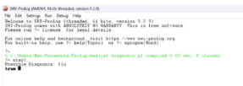
RESULT
The Prolog program for medical diagnosis was successfully implemented. The system uses symptoms, facts, and logical rules to identify a possible disease based on the given

